**VISVESVARAYA TECHNOLOGICAL UNIVERSITY**

**“JnanaSangama”, Belgaum -590014, Karnataka.**



**PROJECT WORK-3 REPORT**

**on**

**AR business card app**

***Submitted by***

**TUSHAR SHARMA(1BM20CS175)**

**TANMAY SINHA(1BM20CS170)**

**UTKARSH(1BM20CS177)**

***Under the Guidance of***

|  |  |
| --- | --- |
| **DR.Rajeshwari BS**  **Assistant Professor, BMSCE** |  |

***in partial fulfillment for the award of the degree of***

**BACHELOR OF ENGINEERING**

***in***

**COMPUTER SCIENCE AND ENGINEERING**



**B.M.S. COLLEGE OF ENGINEERING**

**(Autonomous Institution under VTU)**

**BENGALURU-560019**

**Oct-2022 to Feb-2023**

**B. M. S. College of Engineering,**

**Bull Temple Road, Bangalore 560019**

(Affiliated To Visvesvaraya Technological University, Belgaum)

**Department of Computer Science and Engineering**



**CERTIFICATE**

This is to certify that the project work entitled **“VR business card app**” carried out by **TUSHAR SHARMA(1BM20CS175), TANMAY SINHA(1BM20CS170), AND UTKARSH (1BM20CS177)** who are bonafide students of **B. M. S. College of Engineering.** It is in partial fulfillment for the award of **Bachelor of Engineering in Computer Science and Engineering** of the Visveswaraiah Technological University, Belgaum during the year 2022-2023. The project report has been approved as it satisfies the academic requirements in respect of **Project Work-3 (20CS5PWPW3)** work prescribed for the said degree.

Signature of the Guide                 Signature of the HOD

Dr. Rajeshwari BS Dr. Jyothi S Nayak

Assistant Professor, Dept. of CSE Prof.& Head, Dept. of CSE

BMSCE, Bengaluru BMSCE, Bengaluru

External Viva

Name of the Examiner                                                                                       Signature with date

1._____________________________ ________________________

2. _____________________________ _________________________

**B.M.S. College of EngineerinG**

**DEPARTMENT OF COMPUTER SCIENCE AND ENGINEERING**



***DECALARATION***

We, TUSHAR SHARMA(1BM20CS175),TANMAY SINHA(1BM20CS170), UTKARSH (1BM20CS177),students of 5th Semester, B.E, Department of Computer Science and Engineering, B. M. S. College of Engineering, Bangalore, hereby declare that, this Project Work-1entitled "VR business card app " has been carried out by us under the guidance of Namratha M, Assistant Professor, Department of CSE, B. M. S. College of Engineering, Bangalore during the academic semester Oct 2022- Feb 2023.

We also declare that to the best of our knowledge and belief, the development reported here is not from part of any other report by any other students.

Signature

TUSHAR SHARMA(1BM20CS175)

UTKARSH(1BM20CS177)

TANMAY SINHA(1BM20CS170)

1. Introduction

Welcome to our VR business card app, where we are changing the way people connect and network. Our app provides a unique and innovative approach to business card exchange by offering a more engaging and immersive experience.

With our app, you can create a personalized avatar that represents you and your brand. You can customize your avatar with your logo, colors, and other branding elements to make it uniquely yours. Once you've created your avatar, you can share it with others in virtual reality, making it easy to exchange contact information and connect with potential clients or partners.

Our app allows you to network with people from all over the world, breaking down geographical barriers and enabling you to connect with individuals that you may not have had the opportunity to meet otherwise. It's a fun and interactive way to showcase your brand and personality while making valuable connections that can help grow your business.

So, whether you're attending a conference, networking event, or just looking to expand your professional network, our VR business card app is the perfect tool to help you stand out and make a lasting impression. Download our app today and start connecting in a whole new way.

The functionalities of a VR business card app are:

1. Avatar customization: The ability to create and customize a personalized avatar that represents you and your brand.
2. Business card exchange: The ability to exchange virtual business cards with other users in a virtual environment.
3. Networking opportunities: The ability to connect and network with other users in a virtual environment.
4. Branding and marketing: The ability to showcase your brand and marketing materials in a virtual environment, including the ability to customize your avatar, display your logo, and share other promotional materials.
5. Analytics and reporting: The ability to track and analyze user data and behavior, including the number of business cards exchanged.
6. Integration with other tools: The ability to integrate with other tools and platforms, such as social media, email, and to facilitate follow-up and ongoing communication with contacts made in the app.

2. Design Layouts: Screen Shots of Mobile App / Webpages

2.1: Login Webpage

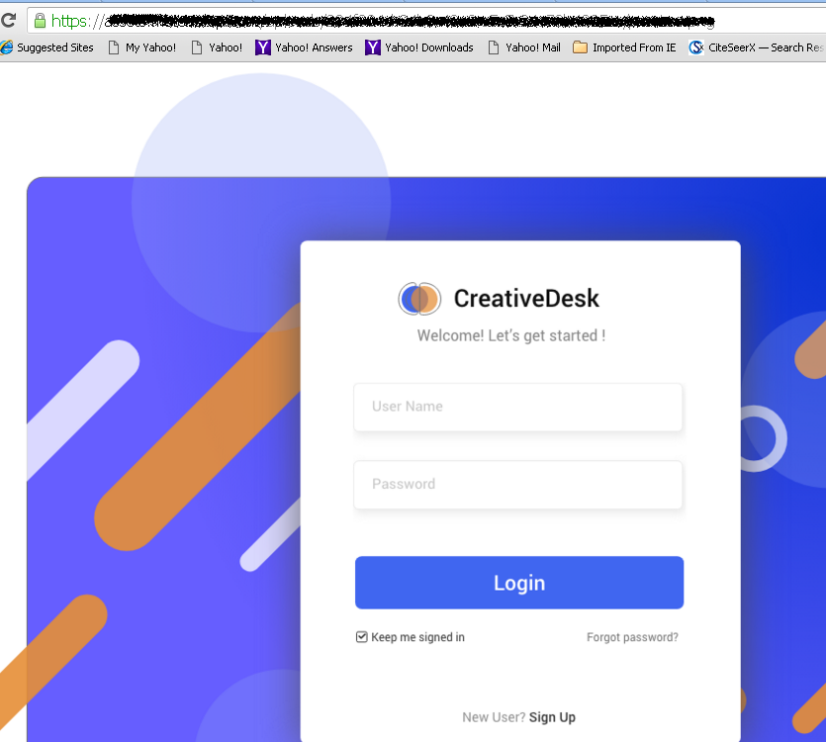

**Fig.1 Login Screen**

2.2: Home Webpage

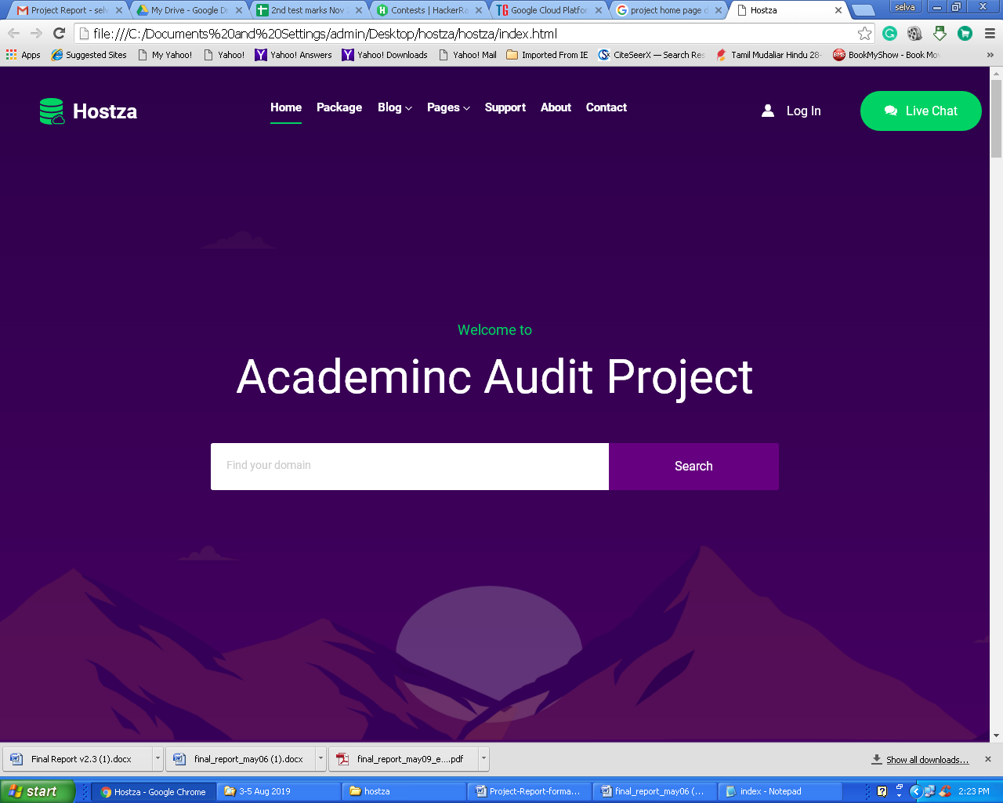

Fig 2. Home Page

3. Database Table Screen shots

*Note: If students are using JSON format for database storage then appropriately the description/data should be shown*

3.1.1. Course Registration Database Table: Description

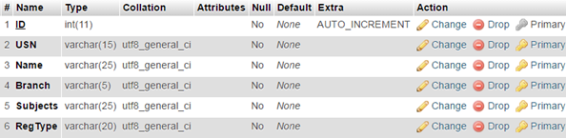

3.1.2 Course Registration Database Table: Data

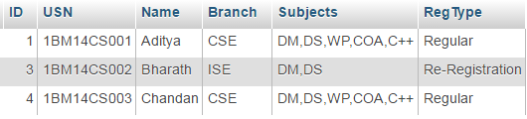

3.2.1. Login Users Database Table: Description

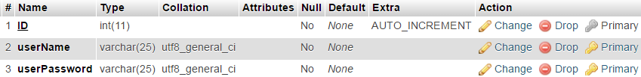

3.2.2 Login Users Database Table: Data



Software and hardware Requirements:

* Android Studio: This is the integrated development environment (IDE) for Android app development. It can be downloaded for free from the Android Developers website.
* Vuforia Software Development Kit (SDK): This is the software development kit for creating augmented reality (AR) experiences. It can be downloaded for free from the Vuforia Developer Portal.
* Unity 3D: This is a game engine used for creating 3D experiences. It can be downloaded for free from the Unity website.
* Firebase: firebase provides detailed documentation and cross-platform SDKs to help you build and ship apps on Android, iOS, the web, C++, and Unity.
* Git: Git is a version control system that can be used to manage source code for the VR business card app. It can be downloaded for free from the Git website.
* VS code: Visual Studio Code is a code editor redefined and optimized for building and debugging modern web and cloud applications.
* Hardware requirements: Android device, Windows 7xor later, Processor: Intel Core i3 or equivalent, or higher, RAM: 8 GB or higher, Graphics Card: Nvidia GeForce GTX 1060 or equivalent, or higher and At least 10 GB of free space on the hard drive.
* Android device requirements: Operating System: Android 7.0 (Nougat) or later.RAM: 2 GB or higher.Storage Space:At least 50 MB of free space on the device,Accelerometer, gyroscope, and magnetometer.
* Learnings from the Project:
* Understanding VR technology: Building a VR app requires a solid understanding of virtual reality technology,and 3D modeling software. Working on a VR business card app project can provide a great opportunity to gain experience with these technologies and learn how to create immersive and engaging virtual experiences.
* UX/UI design: A VR business card app requires a user interface and user experience (UI/UX) design that works well in a virtual environment. Developing a VR business card app can provide an opportunity to learn about UI/UX design principles and how to apply them in a VR context.
* Networking and communication: Developing a VR business card app can provide an opportunity to learn about networking and communication, and how to use them effectively in a virtual environment.
* Android app development: Working with Android Studio provides an opportunity to learn about Android app development, including how to create user interfaces, use Android SDKs, and manage project files.
* Vuforia AR development: Vuforia is an AR framework that can be used to create AR experiences for mobile devices. Working with Vuforia in Android Studio can provide an opportunity to learn about AR development, including how to integrate AR features into an Android app.
* Agile project management: Developing a VR business card app can be a complex and challenging project that requires careful planning and execution. Working on a VR business card app project can provide an opportunity to learn about agile project management principles and how to apply them to ensure the project is delivered on time.

References:

"Getting Started with Vuforia" tutorial from Vuforia: https://library.vuforia.com/articles/Training/getting-started-with-vuforia-in-unity.html

"Introduction to Unity 3D" tutorial from Unity: https://learn.unity.com/tutorial/introduction-to-unity-2018

Designing Virtual Reality User Interfaces" article from Smashing Magazine: <https://www.smashingmagazine.com/2018/04/designing-virtual-reality-user-interfaces/>

"Getting Started with Android Development" from Google Developers: <https://developer.android.com/training/basics/firstapp/>

ARCore Developer Documentation: <https://developers.google.com/ar>

Youtube,Wikipedia and some other reference were also used.